**DAILY ONLINE ACTIVITIES SUMMARY**

|  |  |  |  |  |  |  |  |  |
| --- | --- | --- | --- | --- | --- | --- | --- | --- |
| **Date:** | 20-05-2020 | | | | | **Name:** | K S Prajwal | |
| **Sem & Sec** | Vi A sec | | | | | **USN:** | 4AL18CS032 | |
| **Online Test Summary** | | | | | | | | |
| **Subject** | | OOC | | | | | | |
| **Max. Marks** | | 30 | | **Score** | | | 19 | |
| **Certification Course Summary** | | | | | | | | |
| **Course** | Python for Machine learning | | | | | | | |
| **Certificate Provider** | | | Greatlearning.in | | **Duration** | | | **2 hr** |
| **Coding Challenges** | | | | | | | | |
| **Problem Statement:**  1. reversing a number in python  2. Given an array a[] of size n which contains elements from 0 to n-1, write a program printDuplicates which prints the duplicate elements of the given array. If no duplicate element is found print -1  3. [Write a C Program to Reverse a Linked List (SLL) in groups of given size.](https://github.com/orgs/alvas-education-foundation/teams/2nd-year/discussions/67) | | | | | | | | |
| **Status:** completed | | | | | | | | |
| **Uploaded the report in Github** | | | | | yes | | | |
| **If yes Repository name** | | | | | Lockdown_coding | | | |
| **Uploaded the report in slack** | | | | | yes | | | |

Online Test Details: (Attach the snapshot and briefly write the report for the same)

Certification Course Details: (Attach the snapshot and briefly write the report for the same)

Coding Challenges Details: (Attach the snapshot and briefly write the report for the same)

**Online Test Details**: The online test was from module 1 which was about C++ PROGRAMMING. There were 20 MCQ and 10 program questions and the duration were 30 minutes. The questions were optimal. The score that I received was 19/30.

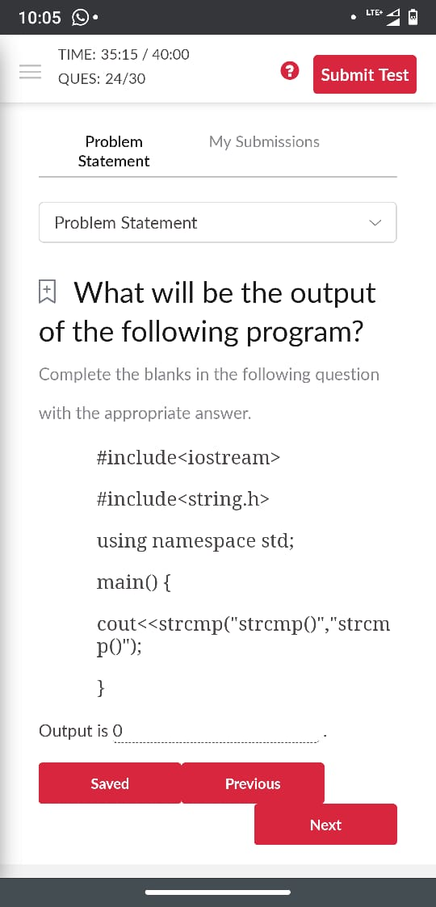**Snapshot**:

Snapshot of certification course:

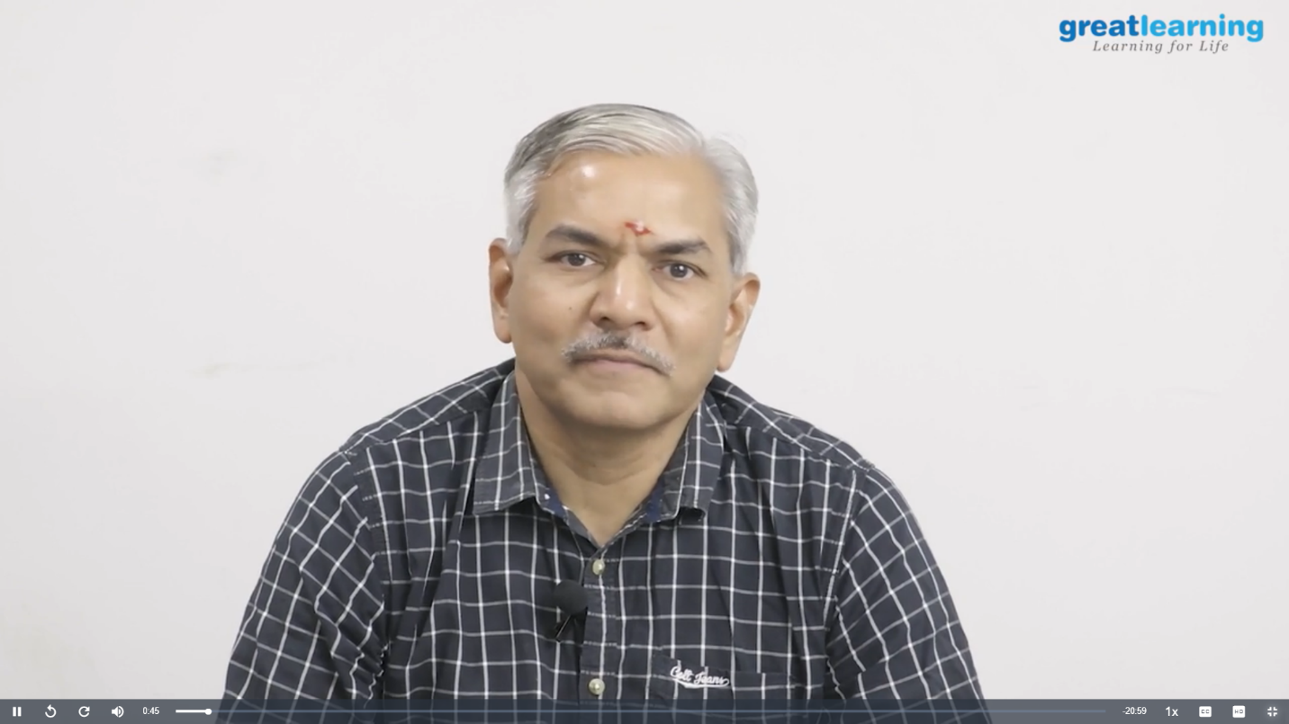

* Pandas and Its Functions.ipynb
* Pandas-Train Dataset
* Pandas-Consumer Dataset
* Pandas- Titanic Dataset
* User Defined Functions
* Lambda Functions
* Classes and Objects

Course completed

**Certificate of completion:**

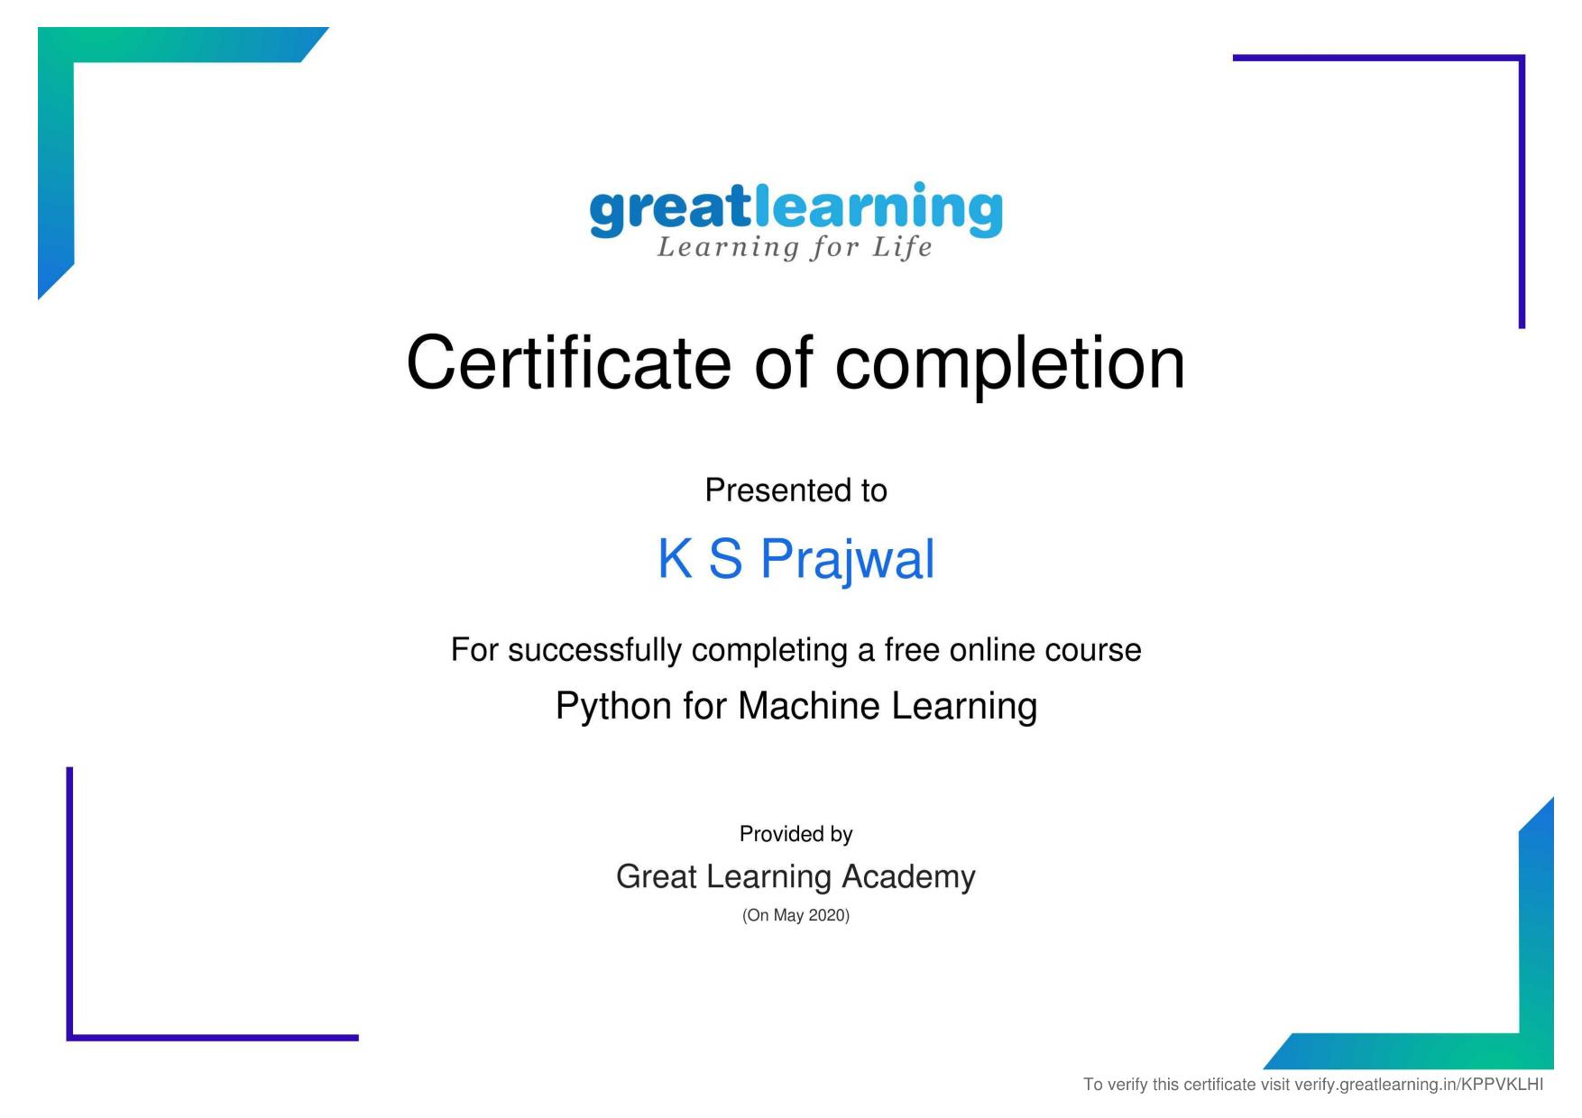

**Online coding:**

Problem 1: Write Python Program to Reverse a Given Number

This is a Python Program to reverse a given number.

Problem Description

The program takes a number and reverses it and store it in another variable and show it

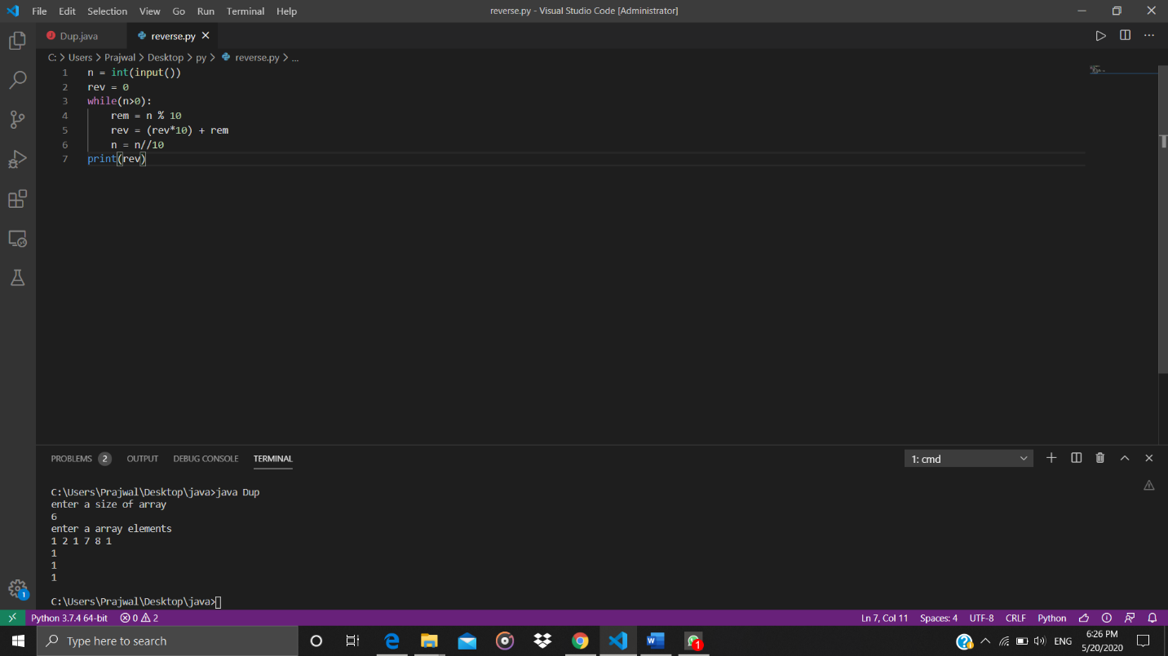

Problem 2: (Using JAVA) Given an array a[] of size n which contains elements from 0 to n-1, write a program printDuplicates which prints the duplicate elements of the given array. If no duplicate element is found print -1.

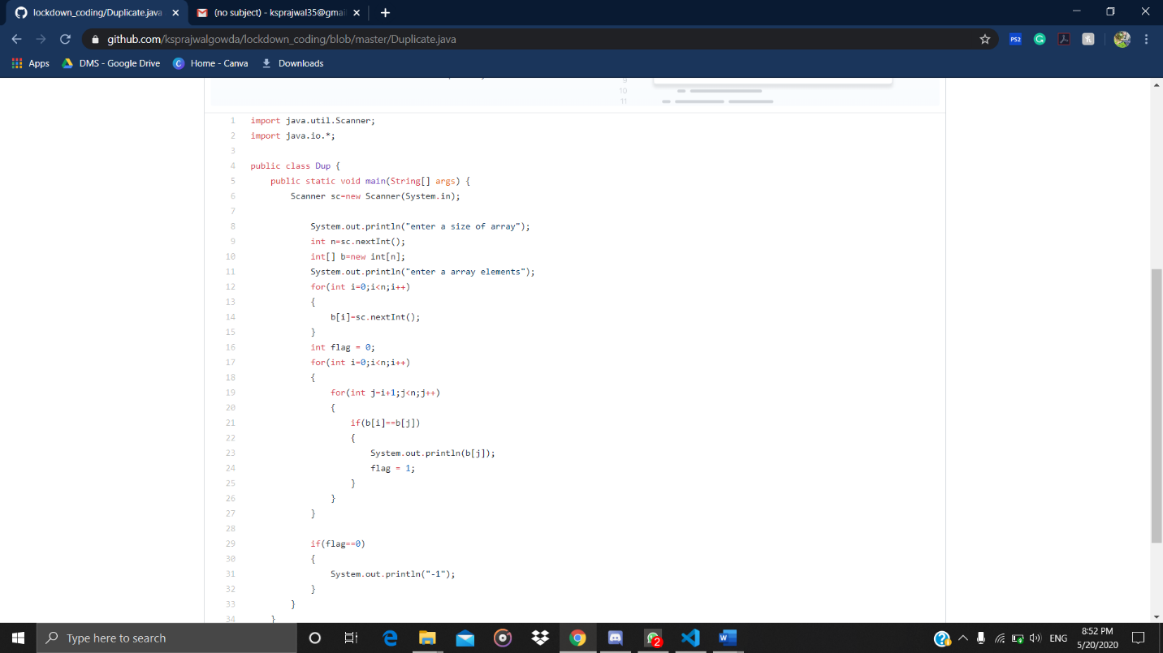

Problem 3: (using C language) [Write a C Program to Reverse a Linked List (SLL) in groups of given size.](https://github.com/orgs/alvas-education-foundation/teams/2nd-year/discussions/67)

